**CHAPTER 3**

**METHODOLOGY**

In this chapter, the methodologies used throughout the study are described together with the diagram presentation. Here are the following sections that will be discussed in this chapter: Requirements Analysis, Requirement Documentation, Design of Software, System Product and/or Process, Development and Testing and Implementation Plan.

**REQUIREMENTS ANALYSIS**

The Red Cross Muntinlupa Center faces significant challenges in managing blood donations, particularly due to manual appointment scheduling and communication gaps between donors and recipients.

**Figure 1.0 Appointment Scheduling**

Red Cross Muntinlupa

Staff

Donor

Manual appointment scheduling at the Red Cross Muntinlupa Center involves donors contacting the center via phone calls or in-person visits, where staff manually collect their information and check available time slots. This process is time-consuming and prone to inefficiencies. There is no automated system for reminders, leading to higher no-show rates as staff may not always have the resources to manually remind donors. On the donation day, staff manually confirm appointments, causing potential delays, and post-donation details are also recorded manually, increasing the risk of errors. Overall, the manual scheduling process is inefficient and resource-intensive, highlighting the need for an automated system to improve efficiency and donor engagement.

**Figure 1.1 Blood Request Process and Communication Between Donors and Recipients**

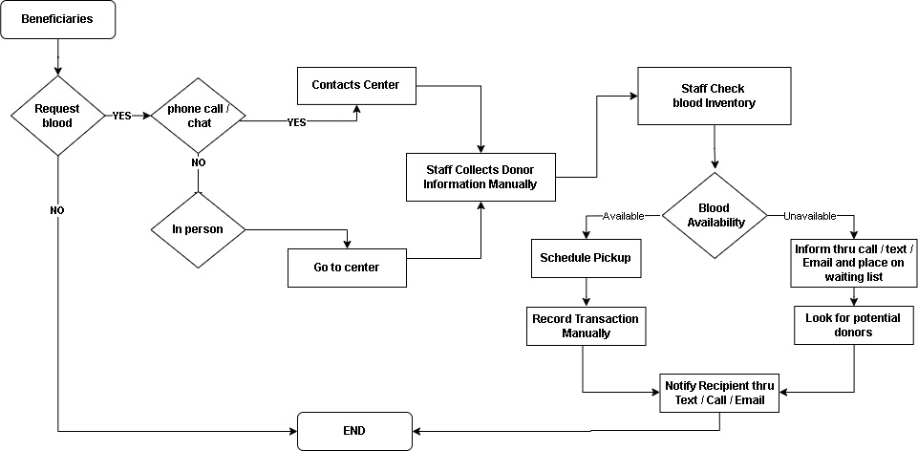

The blood request process at the Red Cross Muntinlupa Center begins when a recipient contacts the center, either by phone or in-person, to request blood. Staff collect detailed information from the recipient, including blood type requirements,

and manually check the blood inventory to determine availability. If the requested blood type is available, staff schedule a pickup or delivery time with the recipient, recording transaction details manually. However, if the requested blood type is not available, staff inform the recipient and may place them on a waiting list, reaching out to potential donors if necessary. Communication between donors and recipients relies on outdated methods such as phone calls and emails, where staff manually contact donors to coordinate donation appointments. Delays in communication often occur due to these manual methods, hindering quick mobilization of donors in response to urgent demands. There is a need to modernize and streamline this communication process to enhance efficiency and effectiveness in coordinating blood donation initiatives at the Red Cross Muntinlupa Center.

**REQUIREMENT DOCUMENTATION**

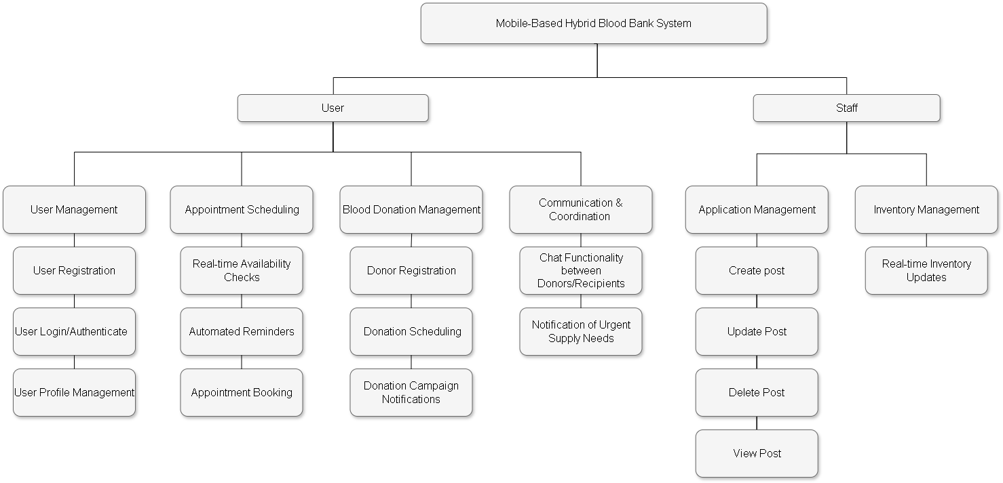

**DESIGN OF SOFTWARE, SYSTEMS, PRODUCT AND/OR PROCESS**

|  |  |  |
| --- | --- | --- |
| **INPUT** | **PROCESS** | **OUTPUT** |
| * **Knowledge Requirements**   **-** Database Management  - Mobile Development  - Backend Development and APIs  - UI/UX  - Mobile App Development Platform  - Backend Development and APIs  - Software tools  - git / github   * **Software Requirements**   - IDE(Visual Studio)  - React Native  - Figma  - Git / Github  - Node Js  - Expo Go  - HTML, CSS, Java Script  - PHP  - Xampp   * **Hardware Requirements**   **-** Computer  - Internet  - Mobile devices | **RAD Methodology**   * Rquirments Analysis and Planning * Software Architecture and Design * System Constructions * Cutover | **Blood Link: A Mobile-Based Hybrid Blood Bank For Red Cross Muntinlupa Chapter** |

**DEVELOPMENT AND TESTING**

**5.1 Development Procedure**

The researchers use the Rapid Application for System Development life

Cycle.

The **Rapid Application Development(RAD)** model is based on prototyping and iterative development with no specific planning involved. The process of writing the software itself involves the planning required for developing the product. Rapid Application development focuses on gathering customer requirements through workshop or focus groups, early testing of prototypes by the customer using interactive concepts reuse of existing prototypes(components) continuous integration and rapid delivery.

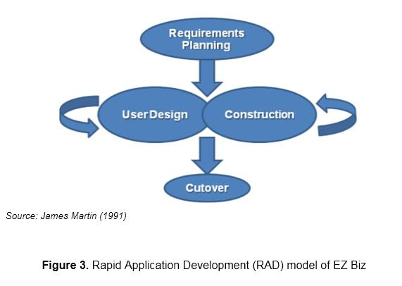

**Figure 1: Phase of Rapid Application Development**

**Phase 1: Requirements Planning**

The researcher first gathers data and plans to develop the system using React Native for the application’s development.

In any case, probably in proposing a system the developers should have talked about the mechanics of the plans first before doing the system. The developers should know the problem of the users and even more in the selected beneficiary. The researchers identify that problem and plans its best solution. To develop the application, the researcher gathered/prepared all the requirements to start the application development.

**Phase 2: Design phase**

The design phase focuses on translating requirements into detailed design specifications. User interface designs, system architecture, and database schema are established during this phase, ensuring a clear roadmap for implementation.

React Native is chosen as the development framework for the mobile application interface due to its ability to provide cross-platform capabilities. This allows the team to develop a single codebase that can run on both iOS and Android devices, streamlining development efforts and reducing time-to-market. React Native's component-based architecture facilitates the creation of reusable UI elements, ensuring consistency across different screens and functionalities within the blood bank application.

**Phase 3: Construction**

During the construction phase, the actual development of the mobile-based hybrid blood bank system takes place. Using the React Native framework, the researchers implement features such as donor registration, appointment scheduling, real-time inventory updates, and communication tools. Continuous integration allows for rapid prototyping and iterative development.

**Phase 4:Cutover Phase**

The cutover phase involves transitioning from the existing blood bank system to the new mobile-based hybrid system. Data migration, user training, and system testing are conducted to ensure a smooth transition. Stakeholder engagement and feedback play a crucial role in validating system functionality and usability.

**5.1 Testing Procedure**

When testing the application to find out where the system fault occurs, a testing technique is required. Even while it cannot ensure that all flaws in a program will be eliminated, if the software is tested effectively and precisely, it can minimize the amount of defects to the absolute minimum.   
To ensure that a program and the system it controls can operate as intended, program tests were carried out in a predetermined order.

|  |  |
| --- | --- |
| **Component / Module** | **Test Conducted** |
| Online database connection of the mobile application. | 1. Tap the check net button on the mobile application. 2. Updated files should be loaded on the mobile app. 3. Try every feature, including CRUD 4. Check if update from administrator site working on the mobile application |
| Data sending from mobile to the website | 1. Select the input box, type in some text message and tap the submit button. 2. Check on the administrator website to see the send message. 3. Check if data entry from the application in on the correct column on database. |
| Real-time update of the system | 1. Add or update a product on the website. 2. Check EZ Biz mobile application to view real-time update of the system. |
| Communication connection | 1. Select from one button in the contact us section in the mobile app (SMS, Call, Email, Website) 2. Initiate communication with a recipient through the app |

**5.1: Project Evaluation**

The evaluation instrument was based on the characteristics and sub-characteristics provided by ISO/IEC 25010:2011.

Respondents of the study were the individual users of the system such as the 10 Information Technology (I.T.) experts and 20 actual users. Purposive sampling was used to select the number of respondents. Purposive sampling is a non-probability sampling technique; it is a form of sampling in which the selection of the sample is based on the judgment of the researchers as to which subjects.

**Table 2**

*System Evaluation Characteristics ISO/IEC 25010:2011 Software Evaluation*

*for both Users and IT Experts*

|  |  |
| --- | --- |
| **Software Characteristics** | **Description** |
| Functionality Suitability | Degree to which a product or system provides functions that meet stated and implied needs when used under specified conditions. |
| Performance Efficiency | Performance relative to the amount of resources used under stated conditions |
| Compatibility | Degree to which a product, system or component can exchange information with other products, systems or components and/or perform its required functions, while sharing the same hardware or software environment |
| Usability | Degree to which a product or system can be used by specified users to achieve specified goals with effectiveness, efficiency and satisfaction in a specified context of use |
| Reliability | Degree to which a system, product or component performs specified functions under specified conditions for a specified period of time |
| Security | Degree to which a product or system protects information and data so that persons or other products or systems have the degree of data access appropriate to their types and levels of authorization |
| Maintainability | Degree of effectiveness and efficiency with which a product or system can be modified by the intended maintainers |
| Portability | Degree of effectiveness and efficiency with which a system, product or component can be transferred from one hardware, software or other operational or usage environment to another |

The statistical tool were used in the interpretation of data is weighted arithmetic mean as shown at table 3. Arithmetic mean is used to determine the average responses of the five option in each item, namely, 5(excellent), 4(very good), 3(good), 2(fair) and 1(poor). The arithmetic means for each software characteristics were computed. These were used to derive the overall evaluation mean.

## Table 3

*Likert Scale*

|  |  |  |
| --- | --- | --- |
| **Scale** | **Range of Mean Value** | **Interpretation** |
| 5 | 4.51 – 5.00 | Excellent |
| 4 | 3.51 – 4.50 | Very Good |
| 3 | 2.51 – 3.50 | Good |
| 2 | 1.51 – 2.50 | Fair |
| 1 | 1.00 – 1.51 | Poor |

**IMPLEMENTATION PLAN**

After finalizing the Blood Link system, it will be presented to the Red Cross Muntinlupa Center for evaluation. If approved for implementation, the complete system and its documentation will be submitted to the Red Cross Muntinlupa Center for deployment.

|  |  |  |  |
| --- | --- | --- | --- |
| **Strategy** | **Activities** | **Persons Involved** | **Duration** |
| Approval from the company | Send letters for the approval of Administrators | Researchers, Administrator | 1 – 2 Days |
| System  Installation | Installation of the system and checking of the facility that needs an upgrade (software and hardware). | Researchers, Administrator | 2 - 3 Days |
| Information Distribution | Send Flyers, Brochures,  Posters, and User Manual | Researchers, Administrator | 1 Day |
| 3- Day  Training | Hands-on Training and System Demo/ Lectures | Researchers, Adviser,  Officer and  Administrator | 3 Days |